Dear Candidate,
Thank you for registering to participate in the Advanced Paediatric Life Support (APLS) course.
Course Program Overview
There are 3 components to the APLS course program.
- Read the 6th edition Advanced Paediatric Life Support manual (digital e-book) – A Practical Approach to Emergencies.

- Complete your APLS Online Learning modules – Approximately 8-10 hours of pre-learning, focusing on key knowledge and clinical priorities in preparation for the interactive 3 day program.

- Fully attend the 3 day face to face program – For application of knowledge through skill stations, workshops, and simulation role play.

Day 1 - Candidate Registration: 09.45
10.00 - 1800
Day 2 - 08.00 - 18.00
Day 3 - 08.00 - 16.15 (approx.)

This information is designed to help make the course an enjoyable and worthwhile experience. Please read this information carefully and do not hesitate to contact the APLS Office for further information or clarification.

Pre-Course Preparation
The face to face course has been designed to build on the knowledge covered in the APLS manual and the pre-course e-learning modules. Please review them prior to attending the course. All e-learning modules will need to have been completed to receive an APLS certificate of completion.
6th edition APLS Practical Approach to Emergencies Manual
You will be sent a 6th edition - Advanced Paediatric Life Support – A Practical Approach to Emergencies – Australia and New Zealand manual in digital format by email.
The digital edition manual can be downloaded onto a compatible PC, Mac, Android, iOS or Kindle device. Refer to the instructions on page 6 of this letter for help installing your e-book.

APLS Online Learning
You will be granted access to the APLS online learning modules from the time you register for the course until one month following the face-to-face program.
To access APLS online learning,
- Log into My APLS

- Scroll down and find the link for ‘APLS online learning’

APLS online learning consists of 8 individual scenario-based modules which are designed to enhance your learning and understanding of clinical priorities for the management of critically ill and injured children. Each module has questions and learning activities for you to complete.
It is anticipated that the pre-course online learning will take you approximately 8-10 hours to complete. Your progress will be monitored by APLS and provided to the Course Director. Reminder emails and text messages will be sent to you one month, 2 weeks and 1 week before the face to face course.

Tips and tricks
- Use Chrome as your preferred browser.
- Consistent and good quality internet connection with no large downloads or streaming going on in the background.
- Check your browser isn’t blocking popups.
- If videos are streaming slowly, click on the small HD icon on video screen so it’s not selected, which will stream in lower quality and speed things up.
- Unfortunately - in some cases, your workplace may restrict access to APLS online learning. In this case, try from home or via your mobile device.
If you experience issues with your APLS online learning modules, please contact APLS on (03) 8672 2800 and we will try to address these asap.

Face to Face Program
The 3 day face to face program is designed to maximise the learning opportunities that occur from clinicians in the face to face environment.

Full attendance is required for all plenaries, skill stations and scenario roleplays.

Formative assessment will occur throughout the 3 days, with mentor meetings and coaching as required.

Formal testing for successful completing of the face to face program includes:

Day 1
- Basic life support skills
- Safe defibrillation skills
- Basic and advanced airway skills

Day 3
- Performance during a simulated scenario situation
- Multiple choice question paper (pass mark 80%)

After the face to face course
APLS Certificate
This will be issued for:
- Completion of APLS Online Learning modules
- full attendance of the face to face program, and
- successful completion of all required assessments on the face to face course

Candidates will be sent an email with certificates attached approximately 10 days after the course.

APLS Online Learning access will be available for 30 days after your face to face course.

Accommodation, Transport and Parking
Candidates are responsible for their own accommodation, transport and parking expenses.
Please review the course schedule (page 5) before confirming travel/flight arrangements to and from the course.
Dress code
You are welcome to wear casual and comfortable attire during the course.
Catering
Catering will be provided during the course.

My APLS

You can find information about your course, links to APLS online learning and your profile/contact details in the My APLS section of the APLS website.
Log in any time via

Need help? Click here for a video guide to accessing My APLS via single sign on.

Have any further questions?
Please contact the APLS Head Office on (03) 8672 2800 during business hours.

Kind regards,
The APLS Team

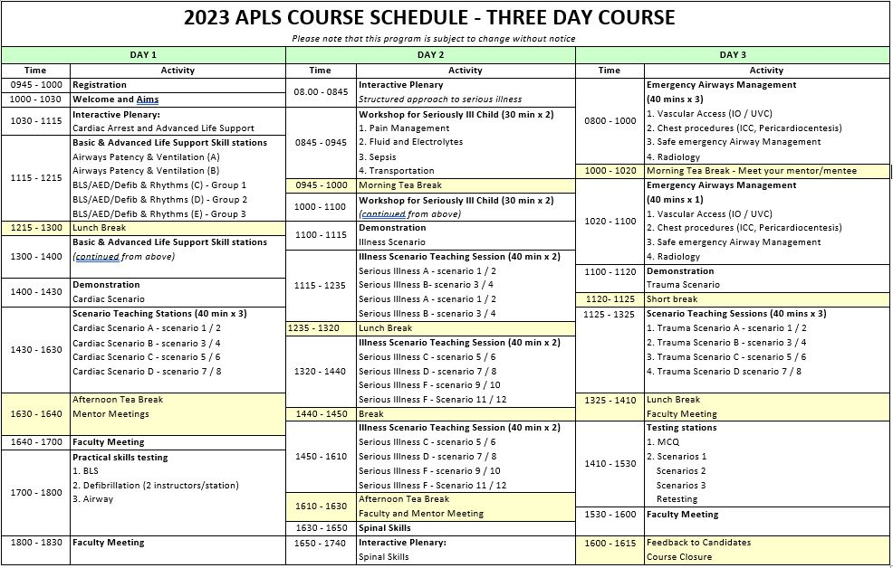

ACCESSING THE DIGITAL VERSION OF THE APLS MANUAL
To access the digital and interactive version of this resource, you will need to create a VitalSource account. You can then use the redemption code supplied to you by APLS or the redemption code on the inside front cover of your print edition to download your manual.
Instructions for accessing the ‘anytime, anywhere textbook’ are on page xxii of the print edition manual. A quick guide is below.
Should you experience technical difficulties, please contact Bookshelf Support via the website or on +61 (0)8 7111 3343.
Getting started with VitalSource Bookshelf®
- To get started, visit http://online.vitalsource.com/ and “Create an Account”
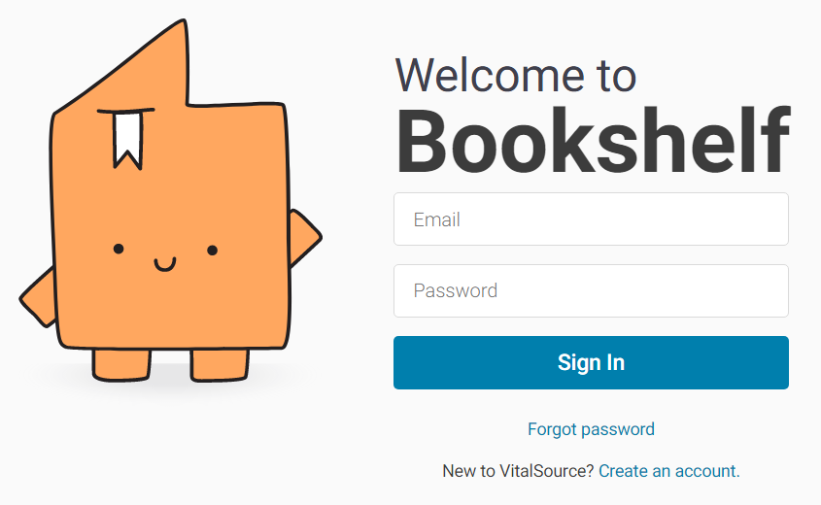

- Complete all the required fields and click Create
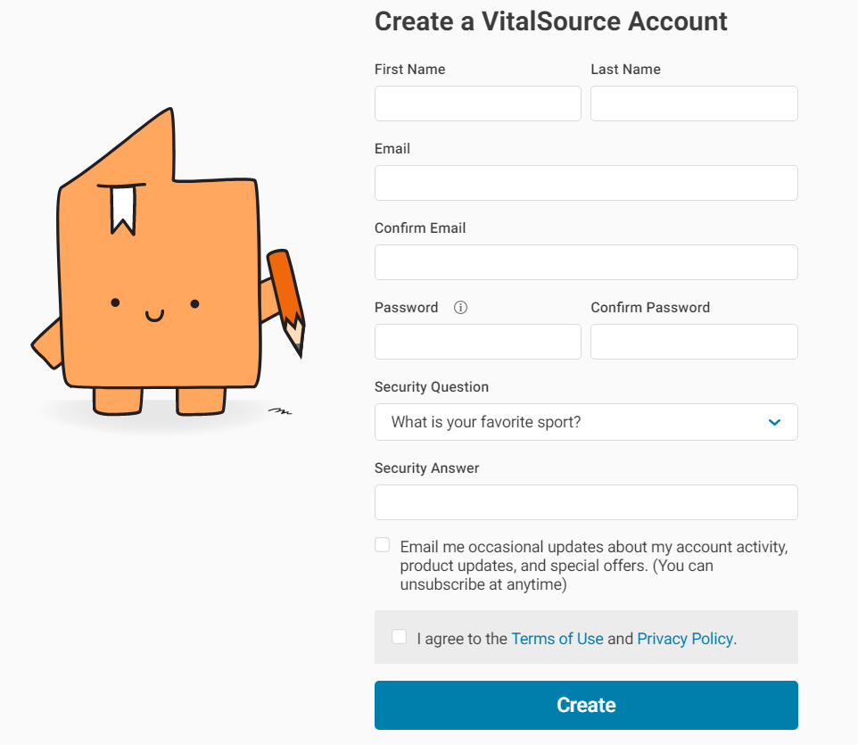


It is important that you remember your email address & password when creating your VitalSource Bookshelf account.

Redeeming your VitalSource redemption code
- Carefully scratch away the top coating to reveal you VitalSource redemption code which is located on the inside cover of your resource.

- Login to your VitalSource account

- Enter your Redemption code and click on the Redeem
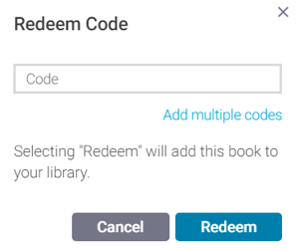

PC Users
PC and Mac users can download books to your personal computer and access them in the VitalSource Bookshelf. They are completely portable; use them whether you are connected to the Internet or not.
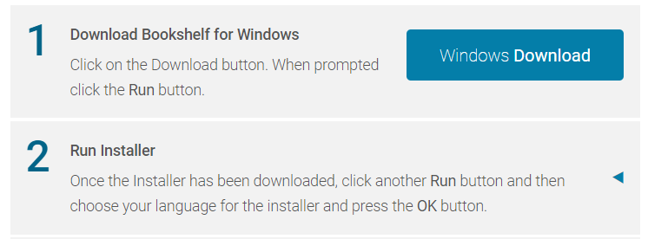
PC Users – Installing VitalSource Bookshelf onto Windows 7/8/8.1.10

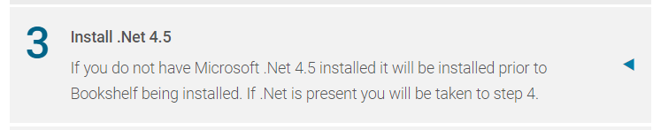

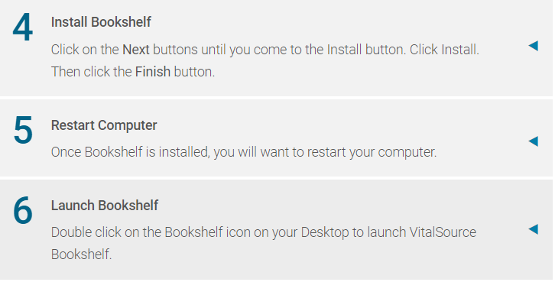

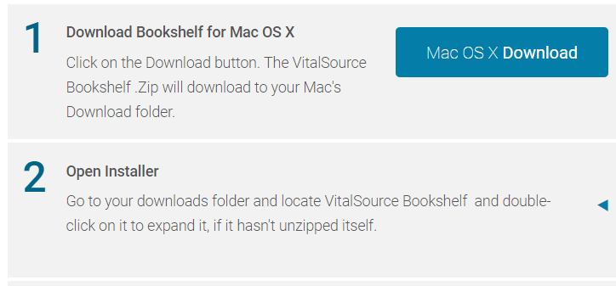
MAC Users - Installing VitalSource Bookshelf onto Mac OS X 10.9 or later

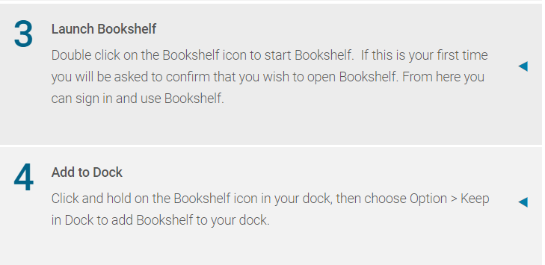

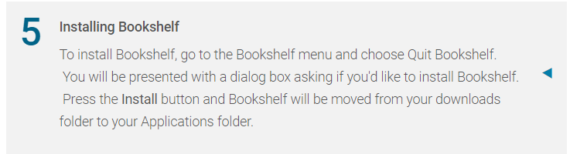

Download VitalSource App - Android/Kindle Fire users – Android 24MB/Kindle 23.7MB
Download your free VitalSource Bookshelf App into your Android smartphone, tablet, or Kindle Fire using Google Play. Access is completely portable with or without Internet access.
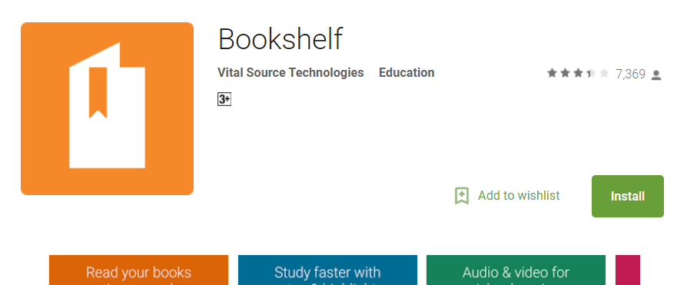
Download VitalSource Bookshelf app from Google Play. Click Install

Installing VitalSource Bookshelf App - iPad, iPhone and iPod touch (66.8 MB)
Download your free VitalSource BookShelf App onto your iPad, iPhone and iPod touch. Access is completely portable with or without Internet access
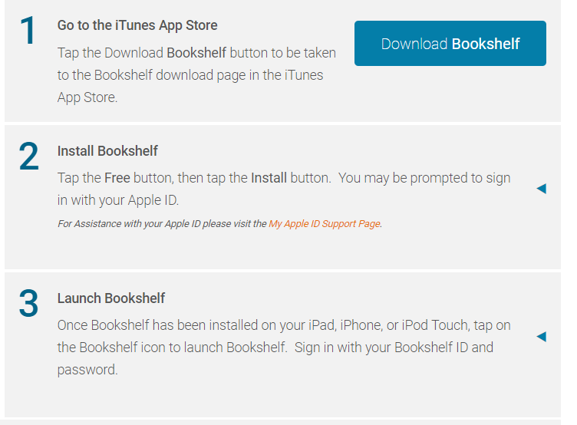

Access to your resource notes
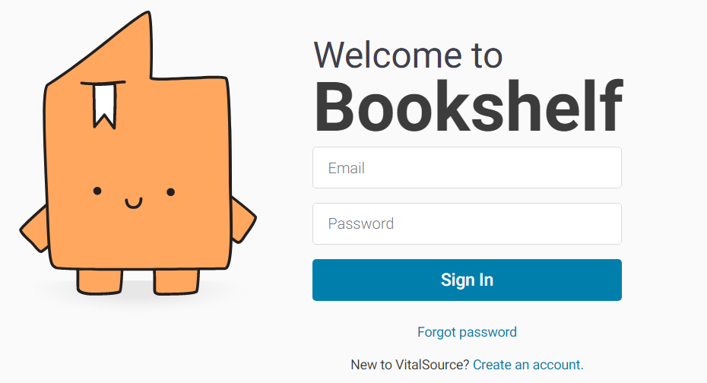
To view your resource notes and highlights, sign into your VitalSource Bookshelf account from any Internet enabled computer.

Forgotten your password?
Click Forgot password, to reset your new password.

