

PRACTICAL SKILL STATION
Spinal Immobilisation

KEY TEACHING OBJECTIVES

Each candidate should receive practical instruction on the following

- Spinal immobilisation

- In-line cervical immobilisation
- Semi-rigid hard collar

- Log-rolling
- Spine Boards and Other Adjuncts (mention only, NO practical instruction)
- Introduction to Trauma Radiology Workshop

EQUIPMENT REQUIRED

Resusi junior x 2
Resusi babe x 2
Paediatric semi-rigid cervical collars x 2 sets
Appropriate measuring devices x 2

ENVIRONMENT

Tables should be laid out in such a way that manikins can be laid down and accessed from all sides

PLAN

Set
"In this station you will discuss the relative indications and contraindications for applying both in-line cervical immobilization and a semi rigid collar as well the clinical criteria for clearing the c-spine and removing a hard collar”

“You will be taught how to perform cervical in-line spinal immobilization and correctly size and fit a semi rigid collar and you will then be shown how to safely and effectively perform a log-roll, both on the small child and infant and the larger child”

“Finally, as in introduction to the Trauma and Radiology Workshop, you will discuss the normal anatomy and radiological findings of the c-spine using the AAABCS approach”

Dialogue
After discussion of the principles and concepts outlined above, this station is taught using the 'silent demonstration' as described in the Preface to Practical Procedures. The following techniques should be taught:

1. CERVICAL SPINE IMMOBILISATION

I. In-line Cervical Immobilisation

The aim of in-line cervical immobilisation is to maintain the child’s head in a neutral position aligned with the body, thus avoiding side-to-side movements

Figure 1.1 In-line cervical immobilisation
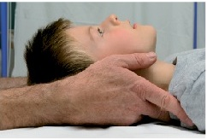
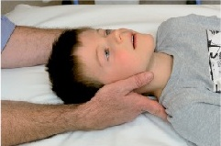

- Stand behind the child
- Place your hands either side of the child’s head with your fingers resting along the neck and just
underneath the child’s shoulders
3. Holding the child’s head, stabilize your arms by either locking in at the elbows or resting your elbows on the ground/bed. The aim is to maintain the child’s head in a neutral position aligned with the body, thus avoiding side-to-side movements

II. Semi Rigid Collar Application

Cervical Hard Collars MUST be fitted correctly. Too large a collar my hyperextend a patient’s cervical spine, too small a collar may not provide appropriate stability

The key to successful, effective collar application lies in selecting the correct size

Procedure

1. Ensure In-line cervical stabilisation is maintained throughout by a second person [see Figure 1.1]

2. Using the manufacturers method, select a correctly sized collar *

See attached document STIFNECK Extrication Collar

3. Fully unfold and assemble the collar

4. With an open hand, grasp the collar length ways and working your hand along the entire length of the collar, squeeze and release, squeeze and release as you go so as to pre-mould and shape the collar into a U shape so as to fit around the patient’s neck

5. Take the Velcro strap on the posterior aspect and fold in onto itself so that it sticks to itself and very gently, taking care not to cause movement, pass the flat part of the collar behind the patient’s neck

6. Grasping the collar underneath the chin support with the webbing between your thumb and index finger, fold [DO NOT PULL ACROSS] the shaped part of the collar with its integral joining device (usually Velcro tape) around the front of the patient’s neck so that the chin support sits well under the chin and until the shaped part of the collar meets the flat part of the collar previously passed behind the neck in the previous step

7. Reassess the correct fit of the collar

8. If the fit is wrong, slip the flat part of the collar out from behind the neck, taking not to cause movement. Select the correct size and recommence the procedure

9. If the fit is correct secure the joining device

Exceptions
An injured child may be uncooperative for many reasons including fear, pain and hypoxia. Manual immobilization should be maintained and contributing factors addressed

Overzealous immobilisation of the head and neck may paradoxically increase the leverage on the neck as the child struggles. The infant or child who is too small for a hard collar should have manual immobilisation supported throughout

Consider - Sometimes the best form of immobilisation is NO immobilisation at all

Children with traumatic torticollis should be manually immobilized in their current position

2. LOG-ROLLING

In order to minimise the chances of exacerbating unrecognized spinal cord injury, non-essential movement of the spine must be avoided until adequate examination and investigation have excluded it

If manoeuvres that might cause spinal movement are essential, then log-rolling should be performed. The aim of log-rolling is to maintain the alignment of the spine during turning of the child

The basic requirements are an adequate amount of carers and good control

Procedure

1. Gather together enough staff to roll the child. In larger children four people will be required; three
will be required in smaller children and infants.

2. Place the staff as shown in Table 1.1

3. Ensure staff members know what they are going to do as shown in Table 1.2

4. Carry out essential manoeuvres as quickly as possible
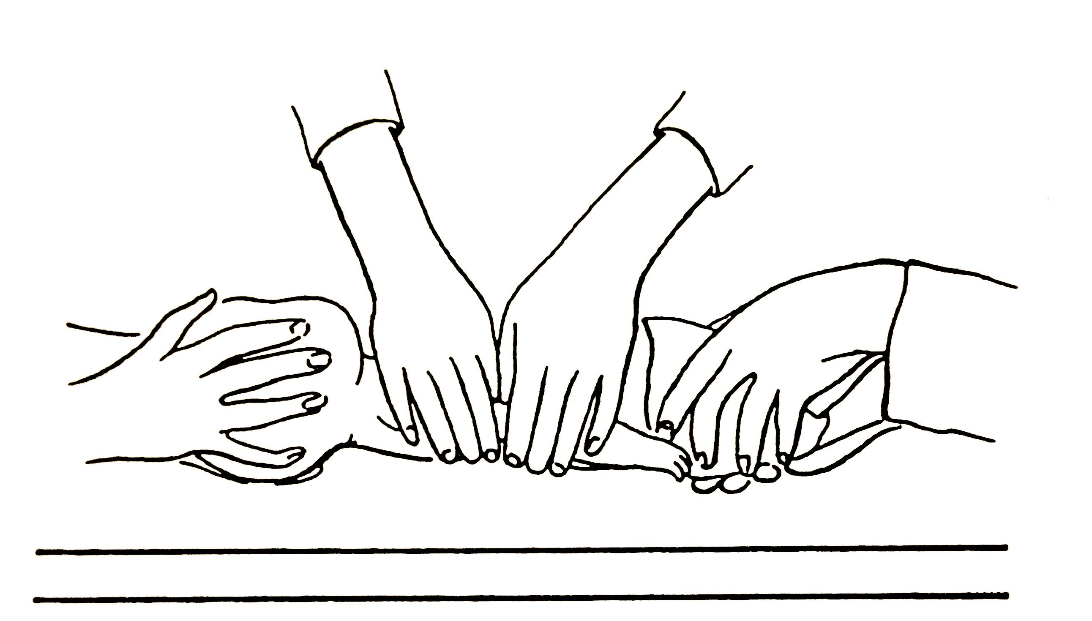
Log – rolling small child or infant: three-person technique

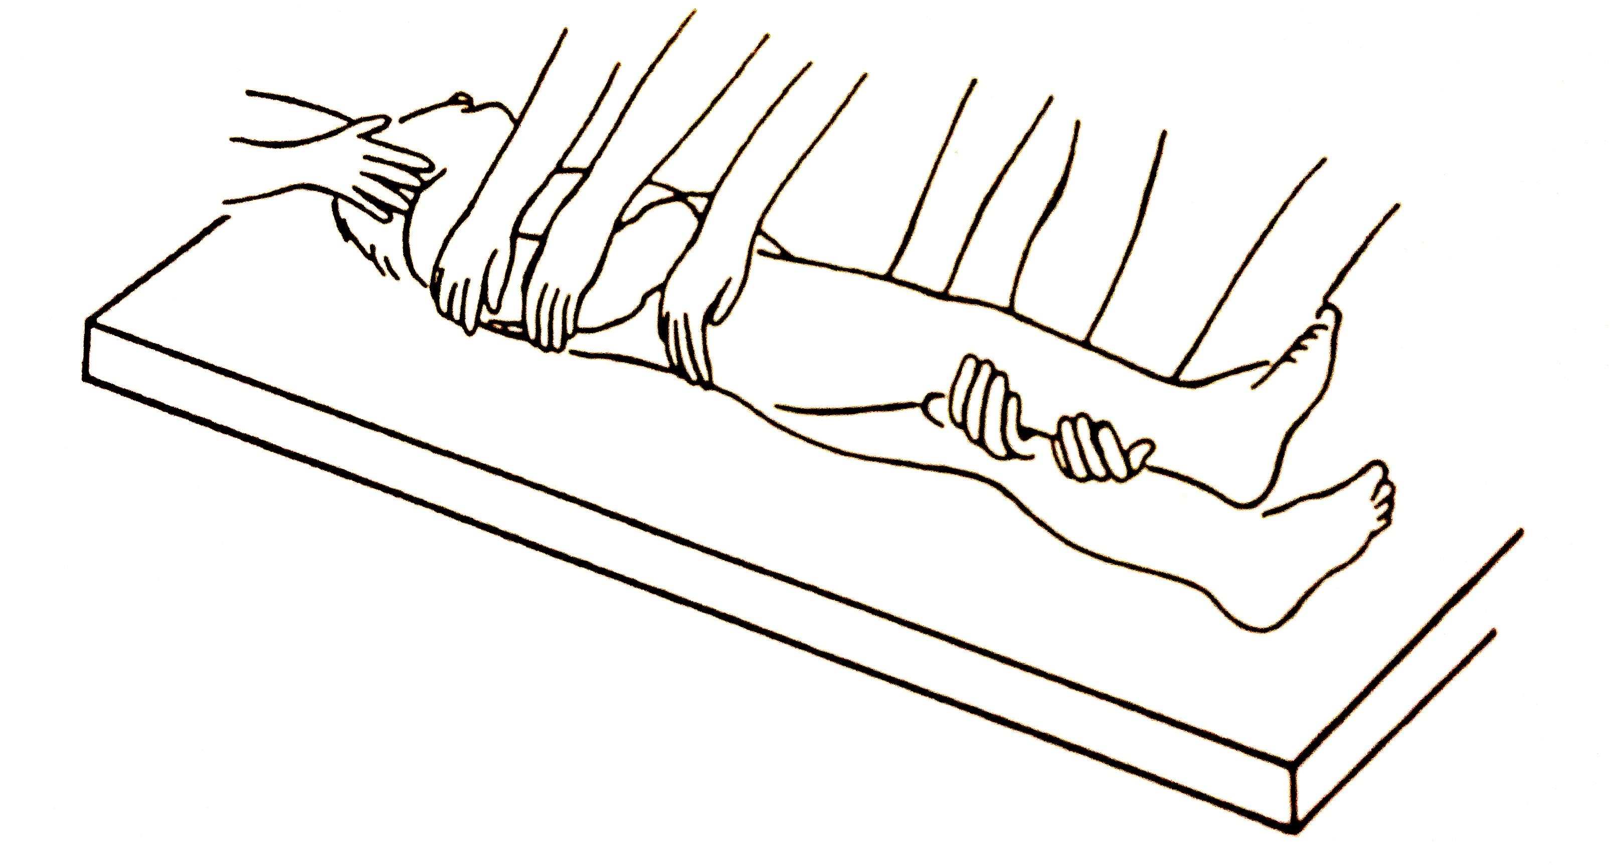
Log – rolling a larger child: four-person technique

Table 1.1 Position of staff for log-rolling

Staff Member | Size of Child
 | Smaller Child and Infant | Larger Child
1 | Head | Head
2 | Chest | Chest
3 | Legs and Pelvis | Pelvis
4 |  | Legs

Table 1.2 Tasks of individual members of staff

Staff Member  Position | Task
Head | Hold either side of the head (as for in-line cervical stabilisation), and maintain the orientation of the head with the body in all planes during turning. Control the log-roll by telling other staff when to roll and when to lay the child back onto the trolley
Chest | Reach over the child and carefully place both hands over the chest. When told to roll the child, support the weight of the chest, and maintain stability. Watch the movement of the head at all times and roll the chest at the same rate
Pelvis and Legs | This only applies to smaller children and infants. If it is not possible to control the pelvis and legs at the same time get additional help immediately. Place one hand either side of the pelvis over the iliac crests. Cradle the child’s legs between the forearms. When told to roll the child, grip the pelvis and legs and move them together. Watch the movement of the head and chest at all times and roll the pelvis and legs at the same rate
Pelvis | Place one hand either side of the pelvis over the iliac crests. When told to roll the child, grip the pelvis and roll it. Watch the movement of the head and chest at all times and roll the pelvis the same rate.
Legs | Support the weight of the far leg by placing both hands under it. When told to roll the child, watch the movement of the chest and pelvis and roll the leg at the same rate.

3. USE OF A LONG SPINE BOARD

Children being transported between institutions may require additional immobilisation. This may involve a spine board, head blocks or a vacuum mattress and where possible, axial loading must be avoided

Children who arrive to hospital on a spinal board MUST be removed from it as soon as possible. Young children have disproportionately larger heads and lie with the neck in a position of flexion when immobilized flat. There is an increased risk of developing kyphosis and anterior translation of the upper cervical segment in an unstable fracture pattern

There is no evidence that spine boards are better than using the bed

4. INTRODUCTION TO TRAUMA RADIOLOGY WORKSHOP

Discuss the normal anatomy and radiological findings of the c-spine using the AAABCS approach

Adequacy
Alignment
Apparatus
Bones
Cartilage and
Soft Tissues

If time allows, you may begin discussing the abnormal c-spine. From here, candidates will then move on to the Trauma Radiology Workshop and continue from where they left off

CLOSURE

Candidates should be given a formal opportunity to ask any questions, when these have been answered to the candidates' satisfaction, the session can be closed by summarising the key teaching points and objectives

ASSESSMENT TECHNIQUE

A record of candidates’ performance during the station should be kept for faculty reference

